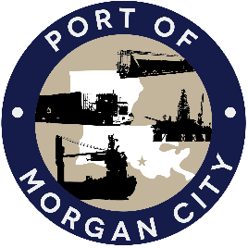

NOTICE OF PUBLIC HEARING

MORGAN CITY HARBOR AND TERMINAL DISTRICT

Notice is given that a public hearing has been called by the Board of Commissioners of the Morgan City Harbor and Terminal District (“District”) and will be held at 7327 Highway 182, Morgan City, Louisiana on Thursday July 28, 2022 at 12:01 p.m. for the following purposes, to wit:

AGENDA

- Presentation regarding proposed Mooring Ordinance preventing the operation or mooring of a vessel in a way that is detrimental to or endangers public safety; is detrimental to the property of others and/or causes delay or hazard to waterway during dredging operations.

2 Public Comment.

3. Adjournment

In accordance with the Americans with Disabilities Act, if you need special assistance, please contact Tori Henry at 985-384-0850, describing the assistance that is necessary.

Publish: July 15, 18 & 22

