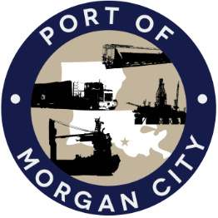

AGENDA

MORGAN CITY HARBOR AND TERMINAL DISTRICT
Regular Meeting of December 10, 2018 – 5:00 p.m. – 7327 Highway 182

- Call to Order

2. Roll Call, Invocation and Pledge of Allegiance

3. Minutes
A. Regular Meeting of November 12, 2018

4. Finance Report
A. Presentation and discussion of financial reports for November 2018 – Deborah Garber
B. Invoices

5. Guest(s)/Public Comment
A. United States Coast Guard
B. Corps of Engineers, New Orleans District

6. Raymond “Mac” Wade - Executive Director’s Report
A. Consultant – Michael Knobloch, Knobloch Professional Services, LLC
B. Consultant – Clay Breaud, Providence/GSE
C. Consultant – Michael Lowe, GIS Engineering, LLC
D. Cindy Cutrera, Manager of Economic Development

7. Gerard Bourgeois - Legal Report

8. New Business
A. Memorial Resolution in honor of Gary Duhon
B. Discussion and any action on resolution requesting authorization to advertise Rail Track Repair and Maintenance port improvement projects under the Port Construction and Development Priority Program

9. Old Business
A. Discussion and any action on leasing, improvements, maintenance and repairs to facility(ies), including Coast Guard lease(s) and HVAC work
B. Discussion and any action regarding the U.S. Department of Homeland Security grant program, including request for proposals, bids, purchases, maintenance for equipment, software and NOAA ports system(s)
C. Discussion and any action on Atchafalaya River Channel including dredging and sediment management, equipment purchases, reports, survey services, consulting services, economic study(ies), landowner agreements and cooperative agreement(s)
D. Discussion and any action on Youngswood Site Development Project, InterMoor lease and rescission of site development purchase

10. Executive Session. Discussion regarding suit against Crosby Marine Transportation, LLC for damage caused to the Morgan City Harbor and Terminal District’s NOAA Meteorological Station #2 in the Atchafalaya River

11. Election of Officers

12. Adjournment

In accordance with the Americans with Disabilities Act, if you need special assistance, please contact Tori Henry at 985-384-0850, describing the assistance that is necessary.

