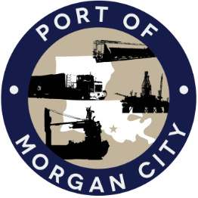

AGENDA

MORGAN CITY HARBOR AND TERMINAL DISTRICT
Regular Meeting of March 13, 2023 – 5:00 p.m. – 7327 Highway 182

- Call to Order

- Roll Call, Invocation and Pledge of Allegiance

- Minutes
- Regular Meeting of February 13, 2023

4. Finance Report
A. Presentation and discussion of financial reports for February 2023
B. Invoices

5. Guest(s)/Public Comment
A. Corps of Engineers, New Orleans District
B. United States Coast Guard

6. Raymond “Mac” Wade - Executive Director’s Report
A. Consultant – Michael Knobloch, Knobloch Professional Services, LLC
B. Consultant – Charles Brittingham, Cassidy & Associates
C. Consultant – Eric Matte, T. Baker Smith
D. Cindy Cutrera, Manager of Economic Development

7. Gerard Bourgeois - Legal Report

8. New Business
A. Discussion and any action on project applications to the FY 2024 Community Project Funding Program

9. Old Business
A. Discussion and any action on leasing, improvements, maintenance and repairs to facility(ies), including warehouse sprinkler system
B. Discussion and any action on Atchafalaya River Channel including dredging and sediment management, equipment purchases, reports, survey services, consulting services, economic study(ies), landowner agreements; right of entry for U.S. Army Corps of Engineers
C. Discussion and any action on Port Construction and Development Priority Program project requests, agreements, engineering, advertising, construction, payments, change orders and substantial completion for East and West Dock Expansion Projects
D. Discussion and any action on Strategic Action Plan and Tariff

10. Executive Session. Discussion on Youngswood yard failure suit #136,621 versus Providence Engineering & Environmental Group, LLC and Patriot Construction and Industrial, LLC

11. Adjournment

In accordance with the Americans with Disabilities Act, if you need special assistance, please contact Tori Henry at 85-384-0850, describing the assistance that is necessary.

