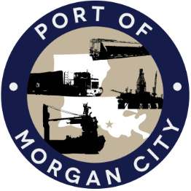

AGENDA

MORGAN CITY HARBOR AND TERMINAL DISTRICT
Regular Meeting of April 14, 2025 – 5:00 p.m. – 7327 Highway 182

- Call to Order

- Roll Call, Invocation and Pledge of Allegiance

- Minutes
- Regular Meeting of March 10, 2025

4. Finance Report
A. Presentation and discussion of financial reports for March 2025
B. Invoices

5. Guest(s)/Public Comment
A. Corps of Engineers, New Orleans District
B. United States Coast Guard

6. Raymond “Mac” Wade - Executive Director’s Report
A. Consultant – Charles Brittingham, Cassidy & Associates
B. Michael Knobloch, Manager of Special Projects
C. Consultant – Robert Karam, T. Baker Smith
D. Consultant – Bill Blanchard, GIS
E. Cindy Cutrera, Manager of Economic Development

7. Gerard Bourgeois - Legal Report

8. New Business
A. Discussion and any action on adoption of millage rate(s) for tax year 2025

9. Old Business
A. Discussion and any action on leasing, improvements, contracts, maintenance and repairs to facility(ies), including warehouse infrastructure improvements, Meteorological Stations, and Port Security Cameras
B. Discussion and any action on Atchafalaya River Channel including dredging/sediment management, equipment purchases, reports, survey services, consulting services, economic study(ies), landowner agreements; right of entry for U.S. Army Corps of Engineers; and barge in slackwater area of locks
C. Discussion and any action on Bulkheading, Drydock, Dredging and Dock Expansion Projects, including agreements, engineering, advertising, construction, payments, change orders and substantial completion
D. Discussion and any action on Strategic Action Plan and Tariff

10. Executive Session. Discussion on Youngswood yard failure suit #136,621 versus Providence Engineering & Environmental Group, LLC

11. Adjournment

In accordance with the Americans with Disabilities Act, if you need special assistance, please contact Tori Henry at 985-384-0850, describing the assistance that is necessary.

